**Database Project**

**Hunain Ali Raza**

**Instructions to build the project**

Restore the database. Change the connection string **“con”** at the top of the following forms:

* Main
* Customer Info
* New sale Purchase

**Document illustrating the various screens and functionality of the system**

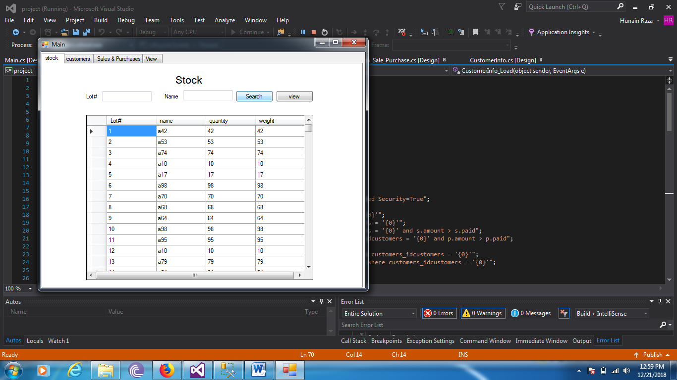

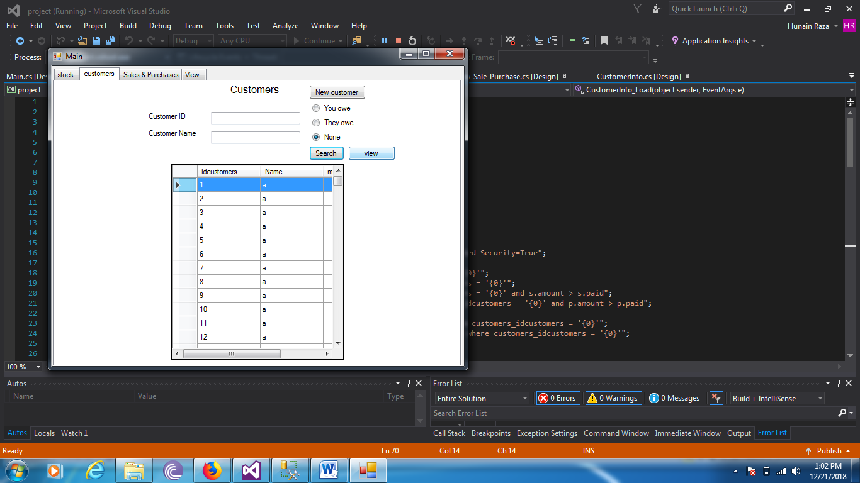

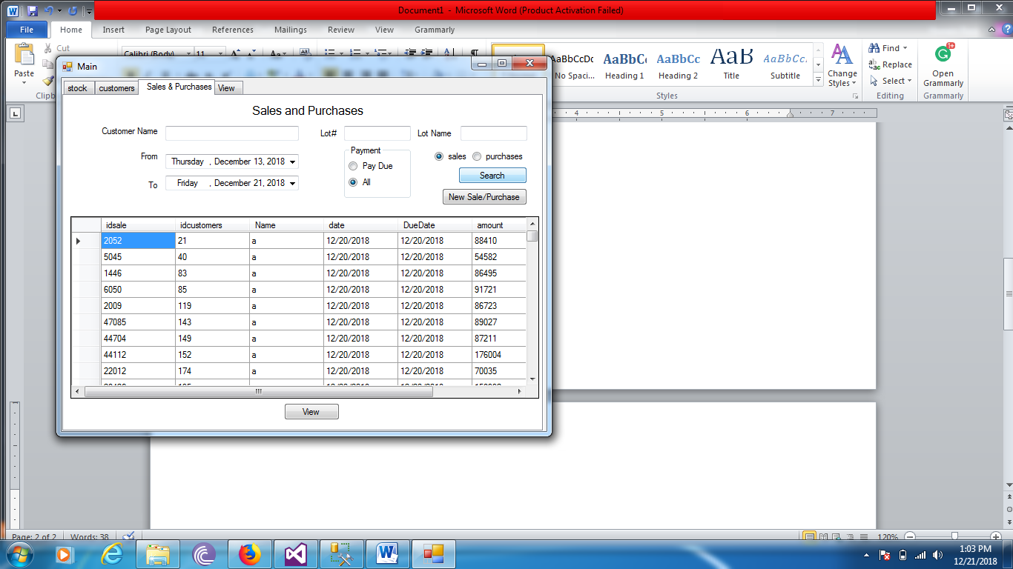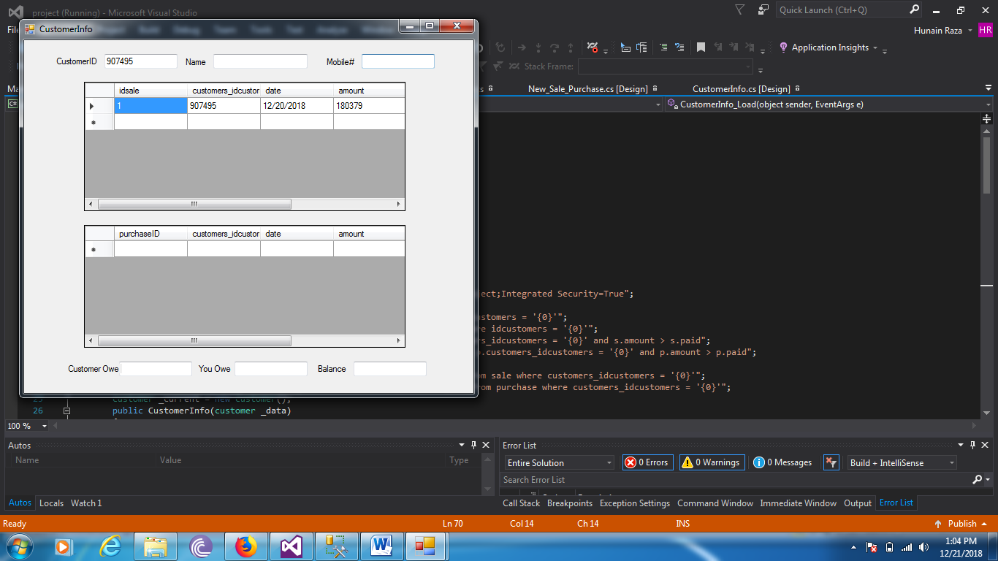

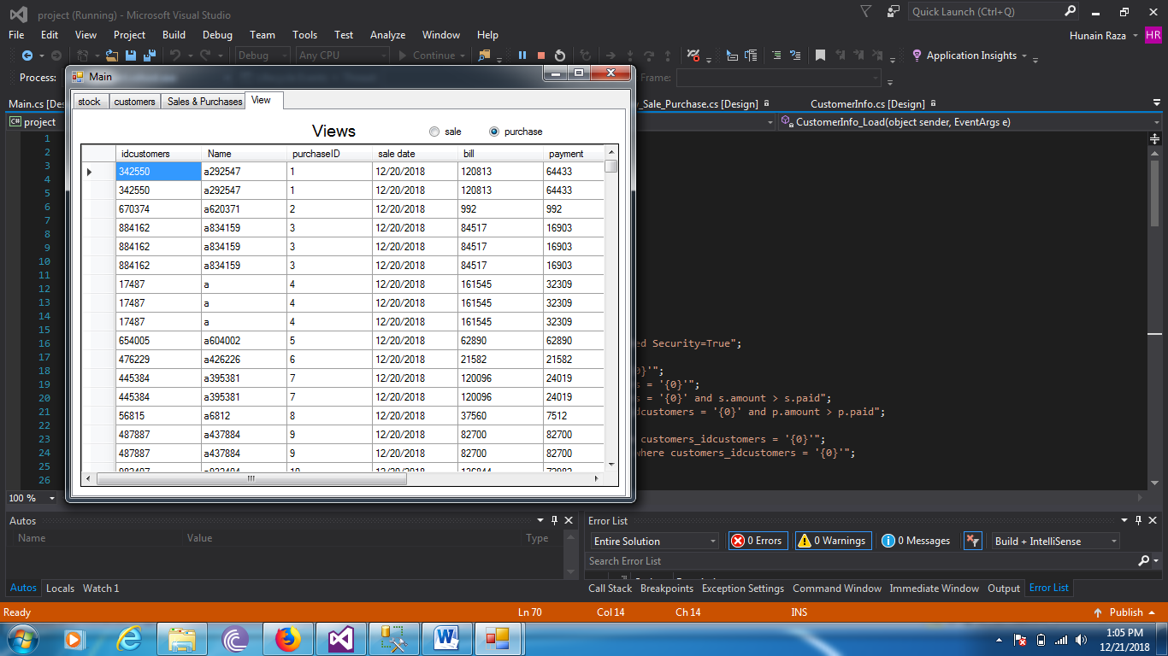

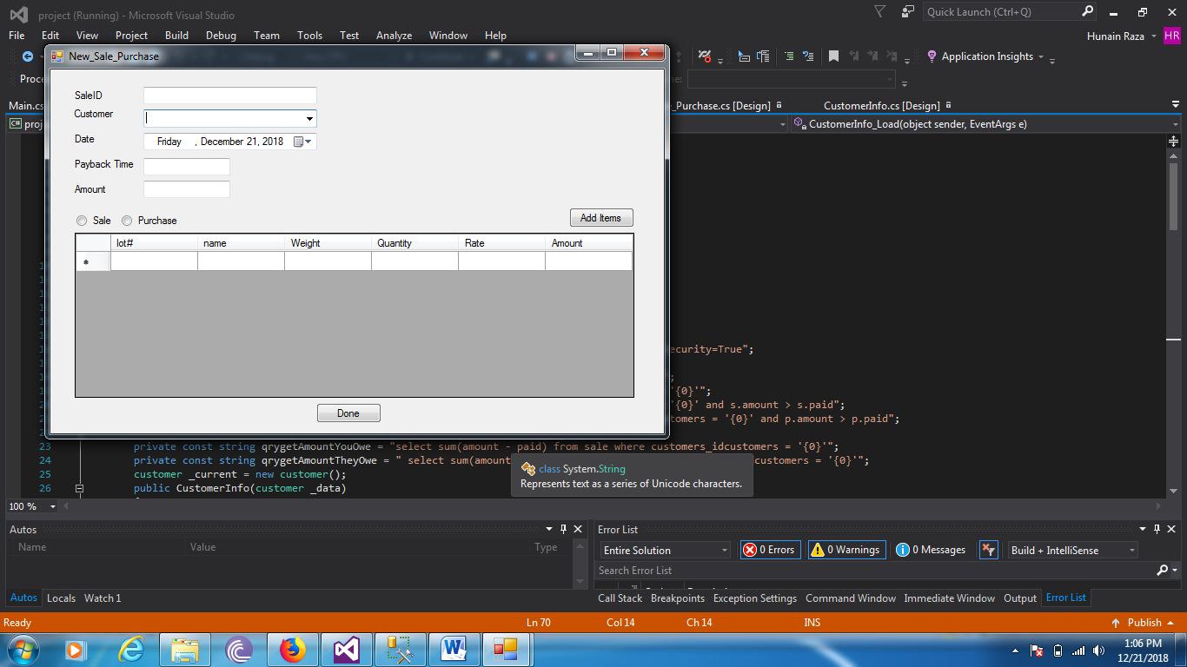

**Functionality**

The above are the search screens and the customer information screen

**How project requirements are fulfilled (trigger, view, stored procedure, data population, etc...)**

* Customer table has a million rows and the all the others except for warehouses have over 50000 rows
* Views are implemented in the main form in the view tab